**AI Documentation Appendicies:**

Appendix 1: Image Processing

Appendix 2: Training Configuration

Appendix 3: Extra Images

**Appendix 1: Image Processing Workflow**

Original Image, Raw Scan:

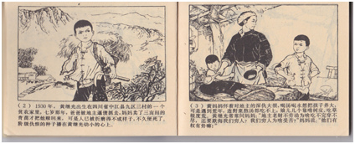

Cropped Image:

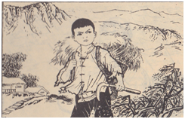

Example of Image Processing:

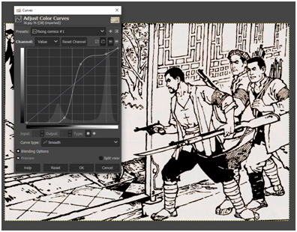

Typical Workflow: apply preset curves; desaturate; adjust brightness and contest using preset

Workflow Speed: 30s/image

Mirrored, Cropped Image (dataset):

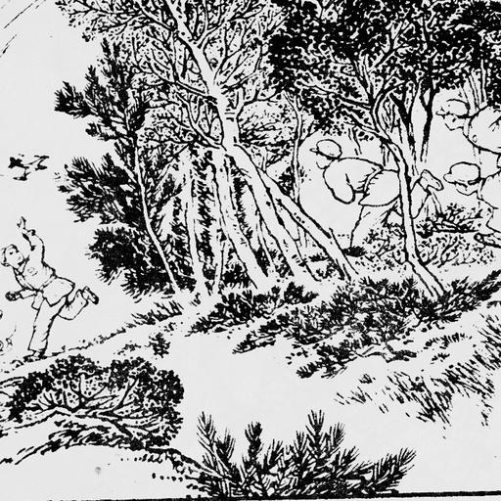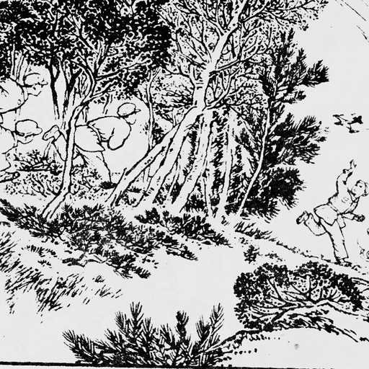

BLIP Caption:

a drawing of a man running through a forest with trees and bushes in the background, with a dog running in the foreground, autumn, autumn_leaves, bare_tree, branch, bush, fence, fireworks, forest, greyscale, leaf, leaf_background, maple_leaf, monochrome, nature, outdoors, palm_tree, park, pine_tree, plant, snowflakes, tree, tree_shade, winter, wisteria

|  |  |
| --- | --- |
|  |  |

**Appendix 2: Training Configuration**

Downloaded from CoLab Notebook Temp Files:

[model_arguments]

v2 = false

v_parameterization = false

pretrained_model_name_or_path = "/content/pretrained_model/AnyLoRA.safetensors"

[optimizer_arguments]

optimizer_type = "AdamW8bit"

learning_rate = 2e-6

max_grad_norm = 1.0

train_text_encoder = false

lr_scheduler = "constant"

lr_warmup_steps = 0

[dataset_arguments]

debug_dataset = false

in_json = "/content/fine_tune/meta_lat.json"

train_data_dir = "/content/drive/MyDrive/images"

dataset_repeats = 10

shuffle_caption = true

keep_tokens = 0

resolution = "512,512"

caption_dropout_rate = 0

caption_tag_dropout_rate = 0

caption_dropout_every_n_epochs = 0

color_aug = false

token_warmup_min = 1

token_warmup_step = 0

[training_arguments]

output_dir = "/content/drive/MyDrive/fine_tune/output"

output_name = "70年小人书"

save_precision = "fp16"

save_n_epoch_ratio = 1

save_state = false

train_batch_size = 1

max_token_length = 225

mem_eff_attn = false

xformers = true

max_train_steps = 2500

max_data_loader_n_workers = 8

persistent_data_loader_workers = true

gradient_checkpointing = false

gradient_accumulation_steps = 1

mixed_precision = "fp16"

clip_skip = 2

logging_dir = "/content/fine_tune/logs"

log_prefix = "70年小人书"

[sample_prompt_arguments]

sample_every_n_steps = 100

sample_sampler = "ddim"

[saving_arguments]

save_model_as = "ckpt"

**Appendix 3: Bonus Images!!!**

